|  |  |
| --- | --- |
|  |  |
|  | |

Barton County Treasurer

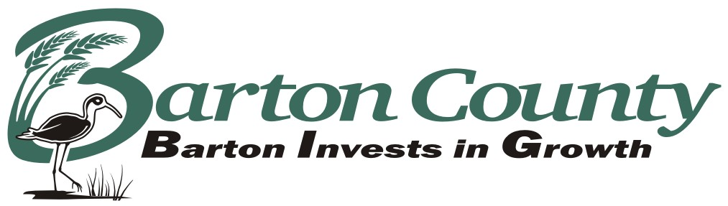

jjordan@bartoncounty.org

James E Jordan, Barton County Treasurer

1400 Main Street Room 208

Great Bend, KS 67530

Phone: 620-793-1827 Fax: 620-793-1978

**Out-of-State Vehicle Tax Refund**

Kansas Statutes provide for a prorated refund of the unused portion of previously paid motor vehicle taxes if the owner of a Kansas registered vehicle has permanently established residence in another State and has re-registered their vehicle in that state.

**Instructions:** All of the following items must be submitted to the County Treasurer’s Office in the County in which the motor vehicle was registered:

( ) Current Kansas owner’s registration receipt (if you cannot find the current year’s registration, include a $1.00 for us to reprint a duplicate registration. If check is sent make payable to Barton County Treasurer)

( ) **A copy** of the applicants driver’s license

( ) **A copy** of the applicant’s current out-of-state vehicle registration.

( ) The valid Kansas License Plate

( ) This form

Current Mailing Address______________________________________________________

City/State/Zip_______________________________________________________________

Phone Number__________________________________

SSN_______________________________

Signature____________________________________

**Refunds of less than Five Dollars ($5.00) are prohibited by law.**

**Missing or incomplete information or documents will delay or reduce your refund.**

**Once your application has been returned to our office and processed, you will receive a refund receipt followed by a check mailed separately in approximately 10 working days.**